The Project FundManager is designed on MVVM Pattern

**Views**: **FundsScreen** : Main screen to display Funds allocated to user, it summary, and panel to add new stock

**Model**: **Stock**: Model for All Funds

**StockValues** : Model for Summary of Fund Data

**StockEnum**: Enum for Stock Type- Equity or Bond

**ViewModel** : **FundScreenViewModel** – This holds properties/commands which are binded by views and populate Model and show its data on view

**Helper Classes**

**ResourceDictionary** – For Common global styles

**StockNameHighlightConverter** : This will make Stock highlight according to specified condition.

FundManagerTest includes the testcases for these classes.

**SCREENSHOTS**

Main Funds Screen: Top - Have a panel to add Equity Stock or Bond Stock

Middle Left – Grid to show all funds

Middle Right – Grid to show Funds Summary

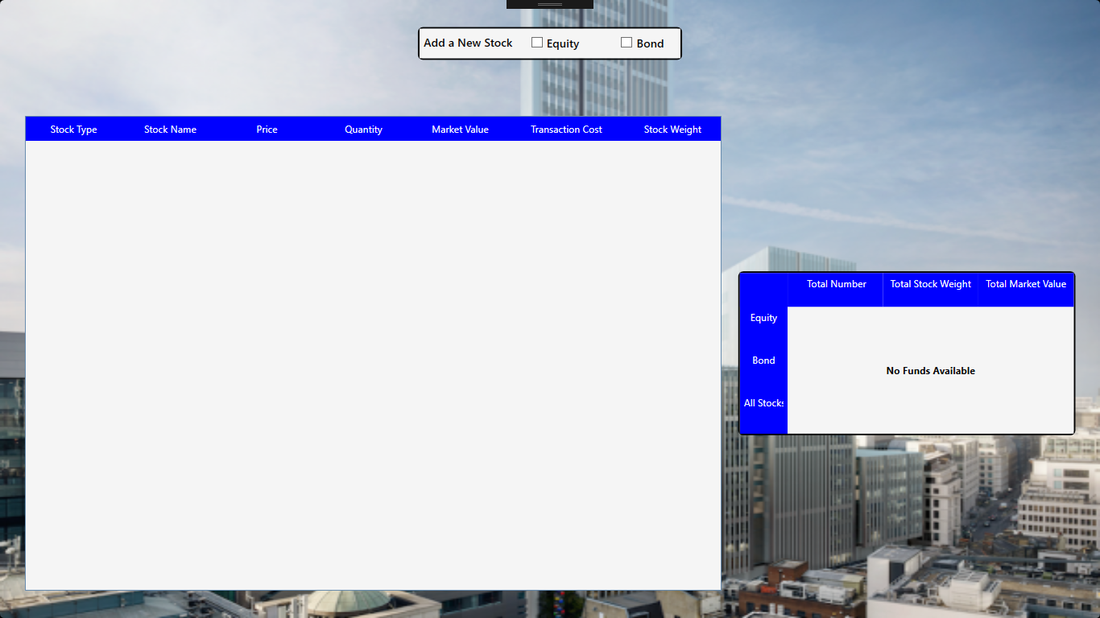

On Selecting to add Equity Stock – A new panel is visible to add price and quantity of Equity Stock

Add Stock button is disabled as Price and quantity are not set.

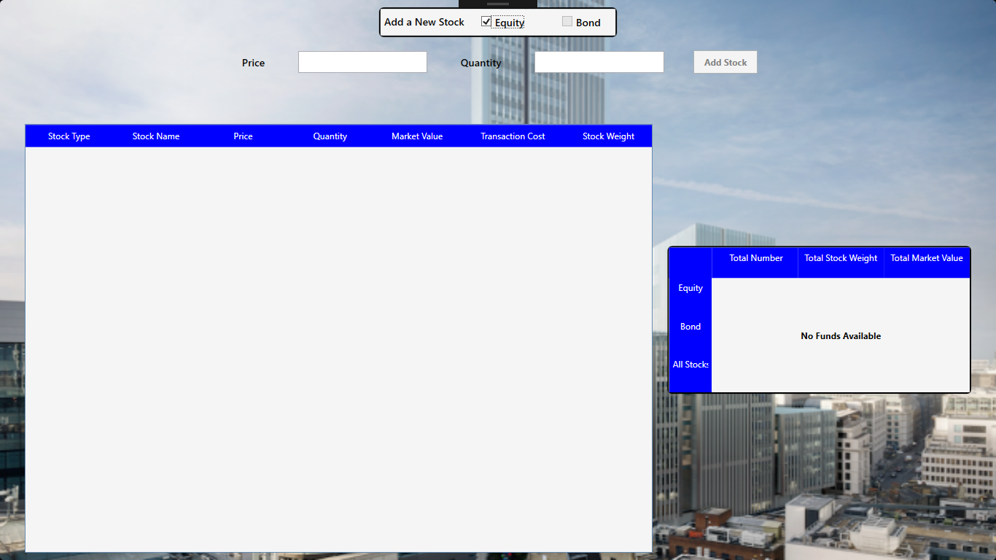

On adding Price and Quantity, Add button gets enabled. Price textbox can accept negative decimal numbers ( - , . , 0-9) . It will reject all other characters/symbols. Quantity textbox will accept only numbers (0-9). Add Bond checkbox is also disabled as user can add only 1 stock at a time.

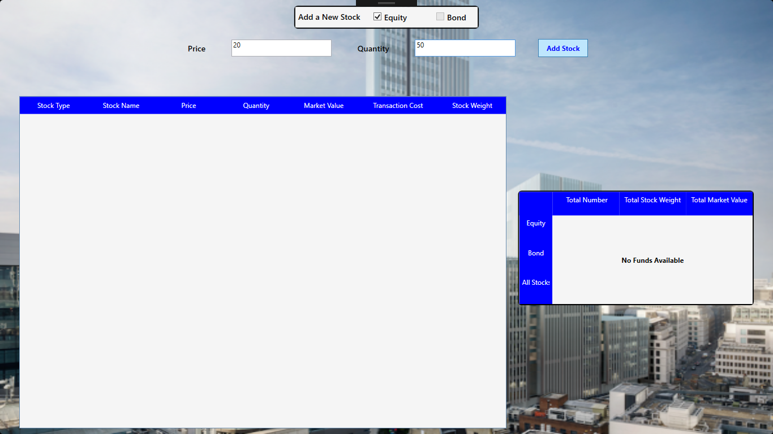

If User Add Stock

* Equity and Bond checkboxes are clear
* Add Stack Panel is now hidden
* Grid is filled with new stock data
* Stock Name is “Equity1”
* Fund Summary Panel Shows summary of data

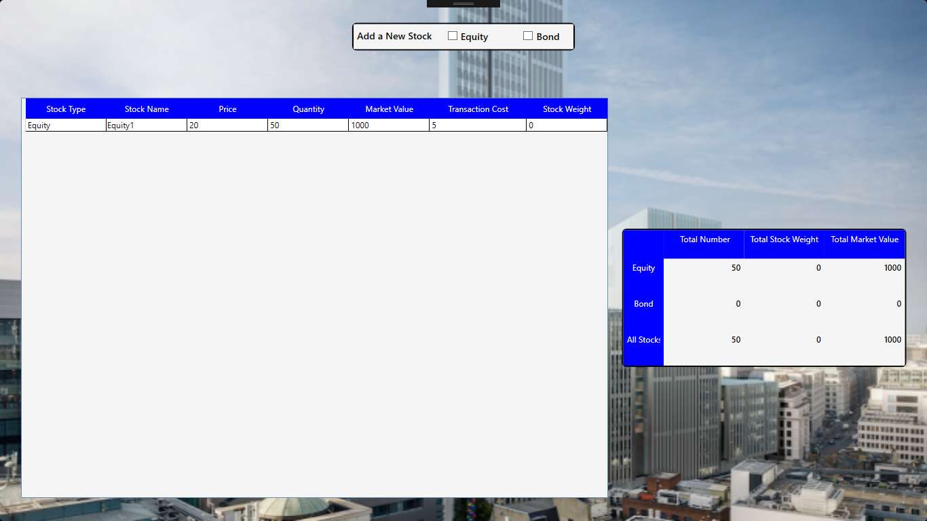

On Adding Bond – new bond name is Bond1

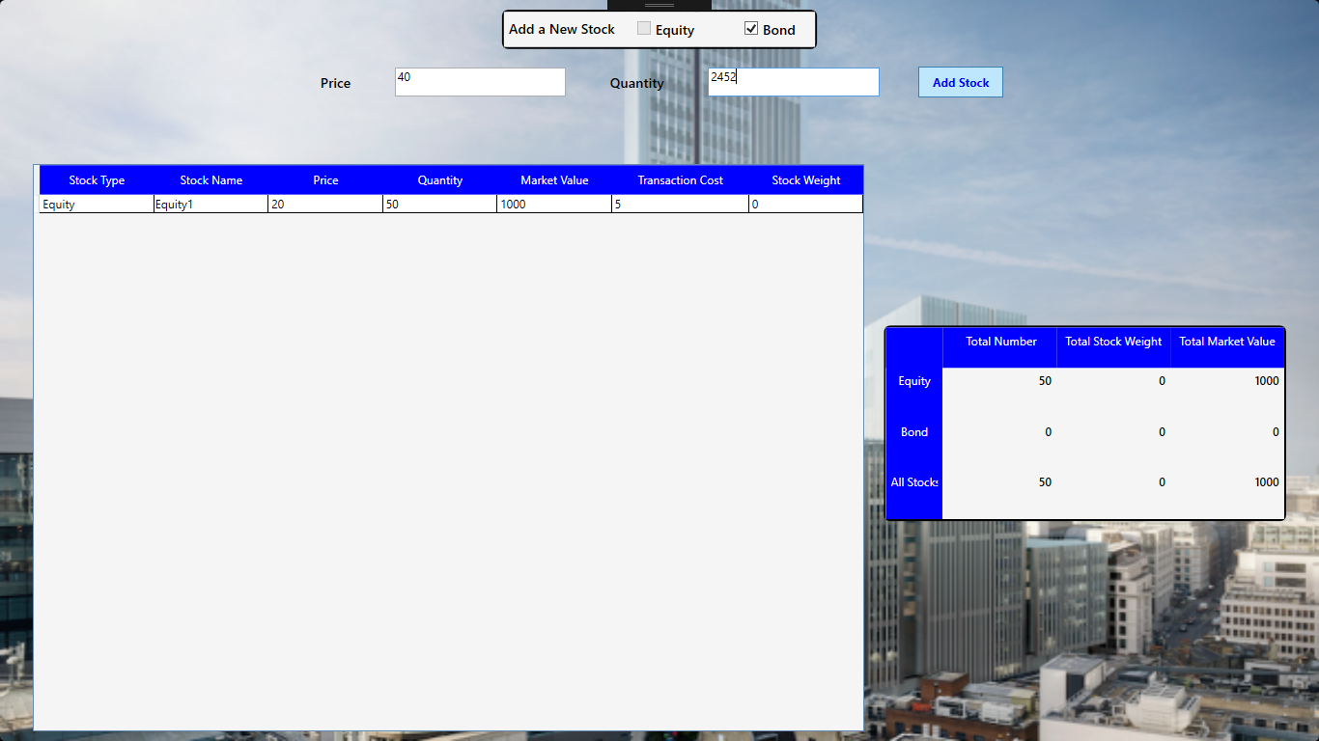

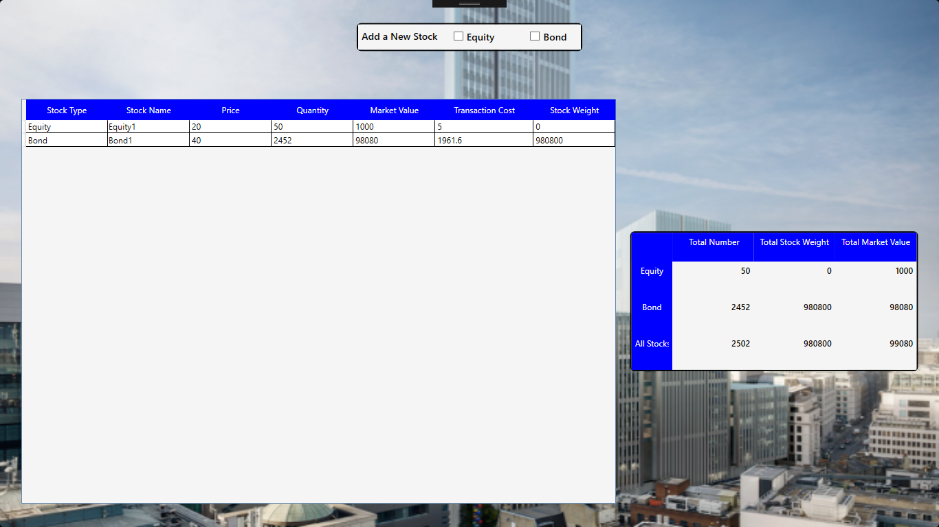

On Adding an equity again, Stock Name is generated as Equity2

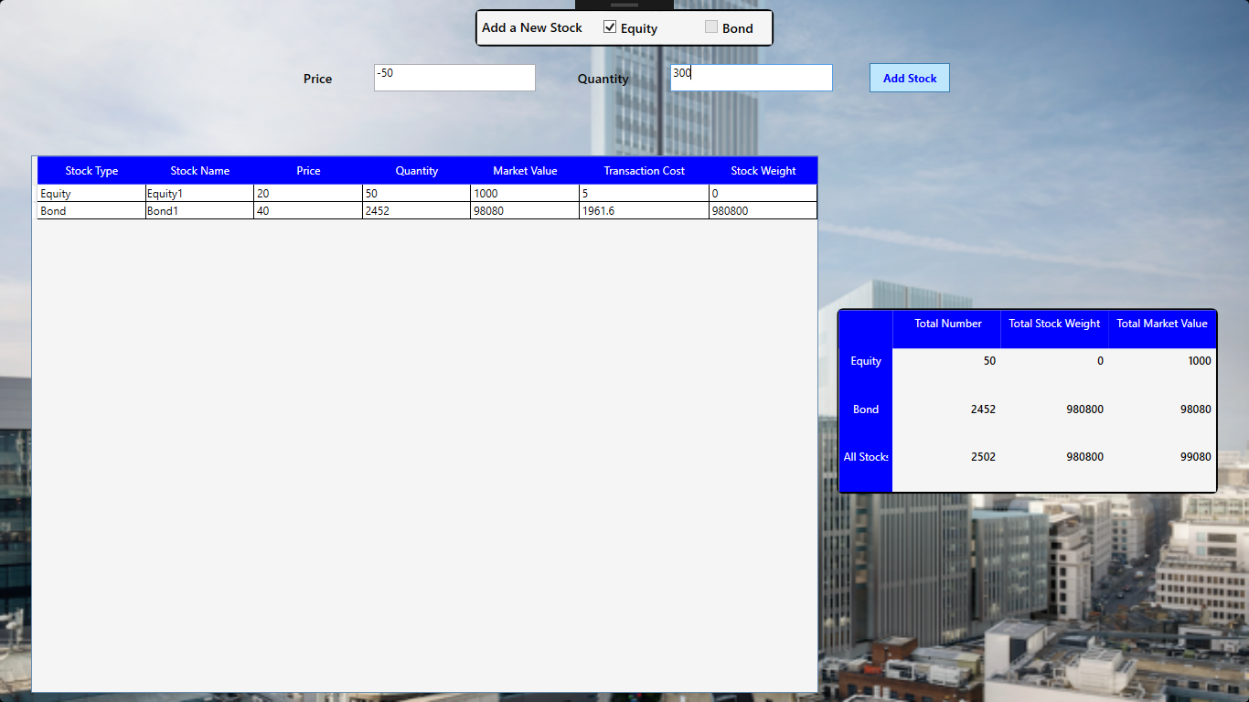

Since market Value < 0, Equity2 is highlighted

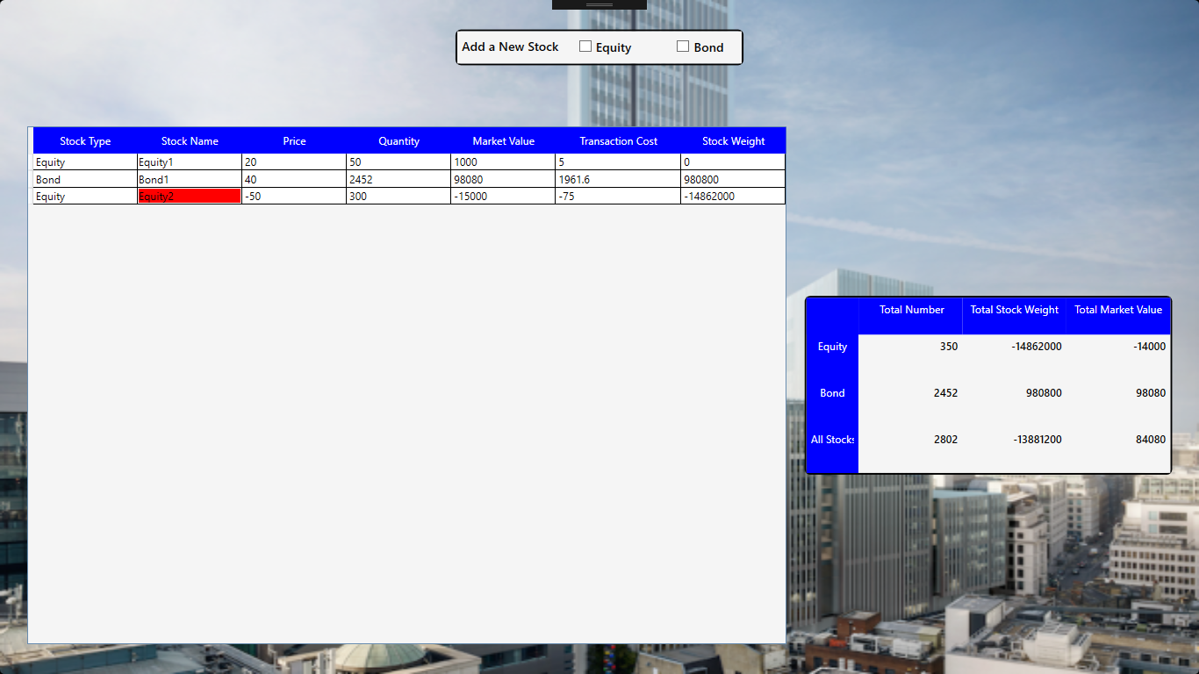

On adding a new Equity again with Price = 250000 and quantity = 200,

Equity4 is also highlighted as Transaction Cost > 200000(tolerance for equity)

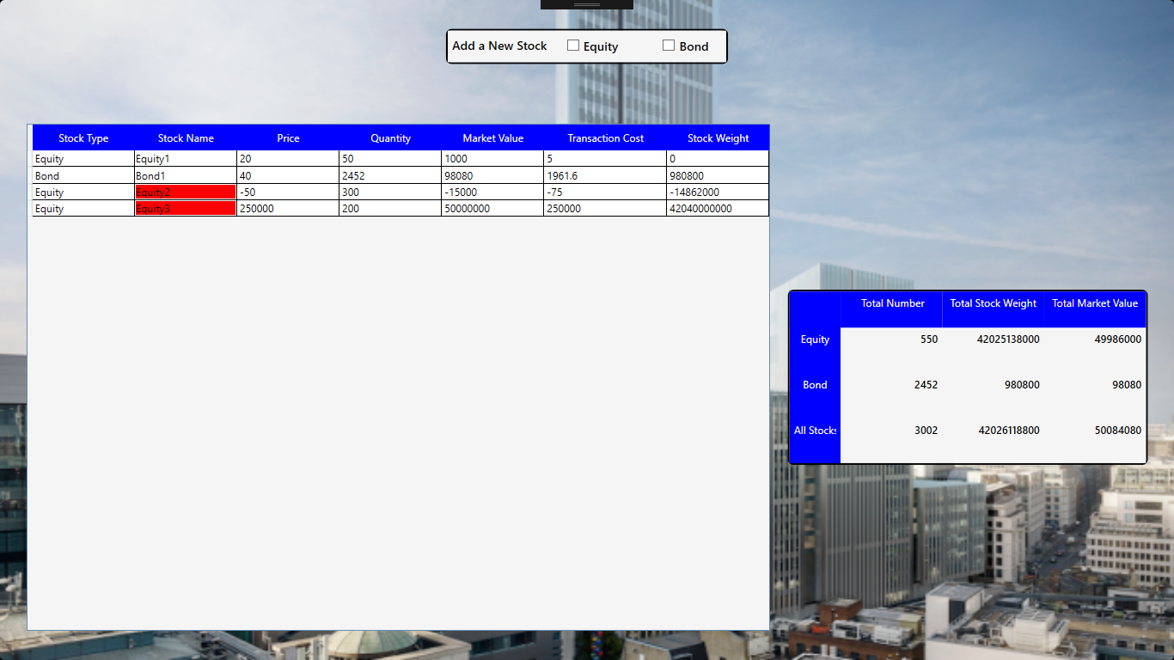

In another example

On adding new Bond with Price = 150000, quantity = 100

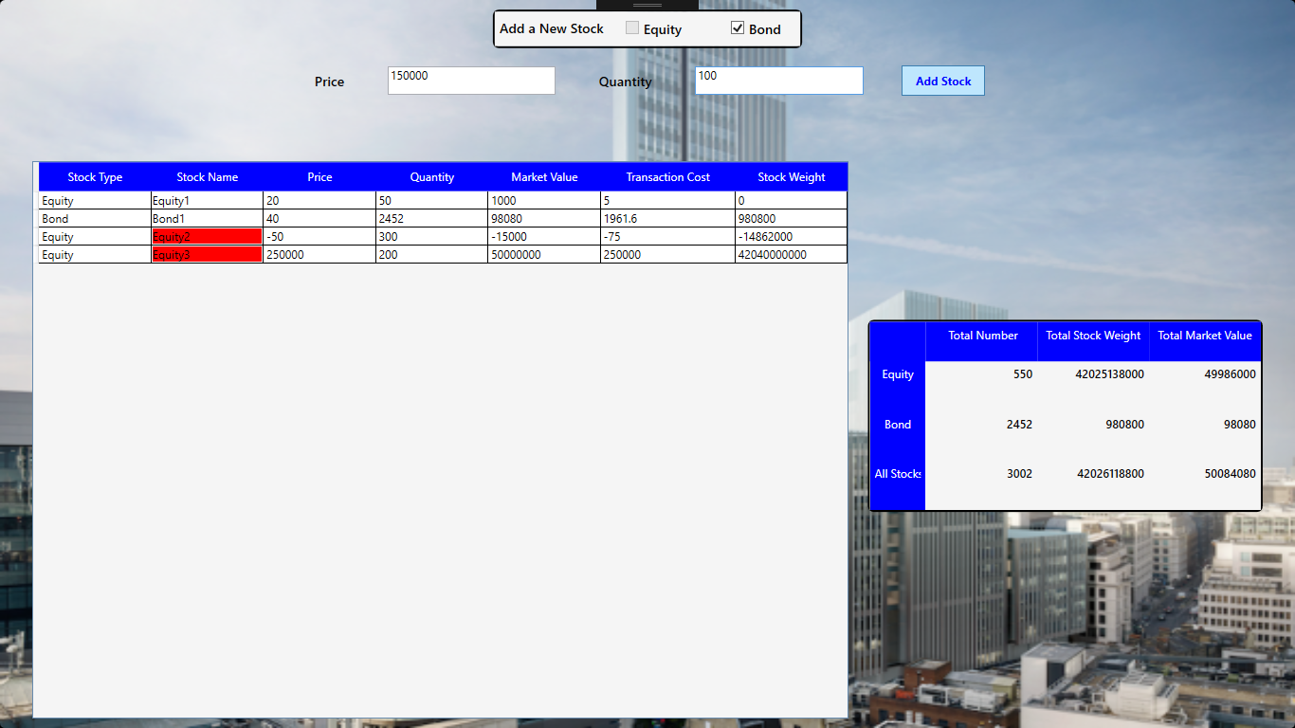

Bond2 is highlighted as Transaction Cost > 100000 Tolerance for Bond

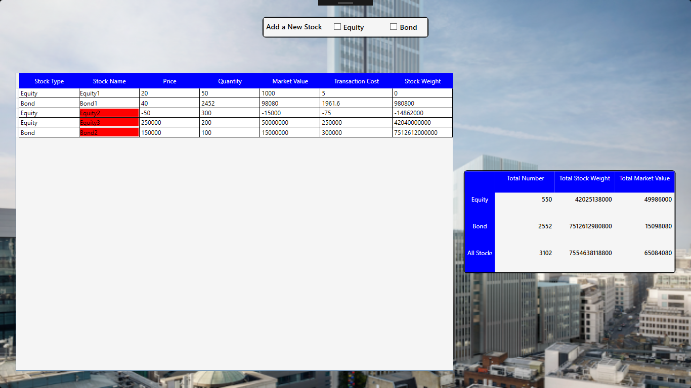

If user click on checkbox to add stock and enters some value

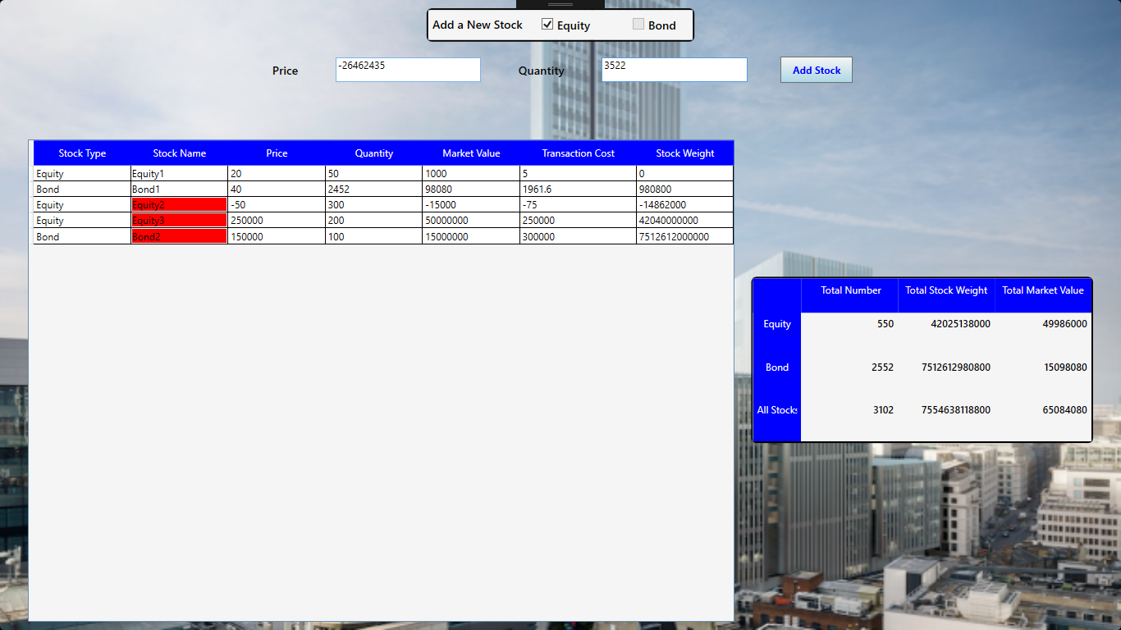

And then decided not to add stock, and uncheck its checkbox

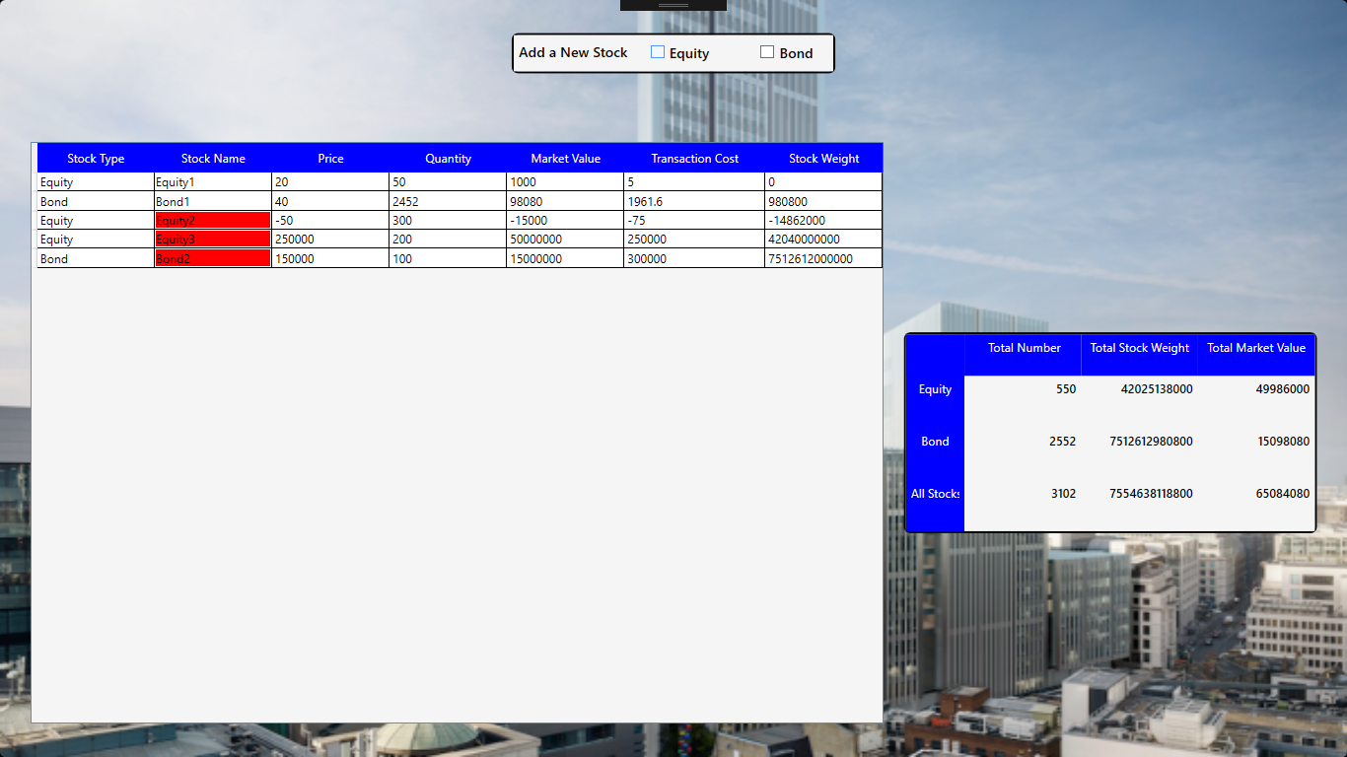

When he check the checkbox again – price and quantity textboxes are empty.

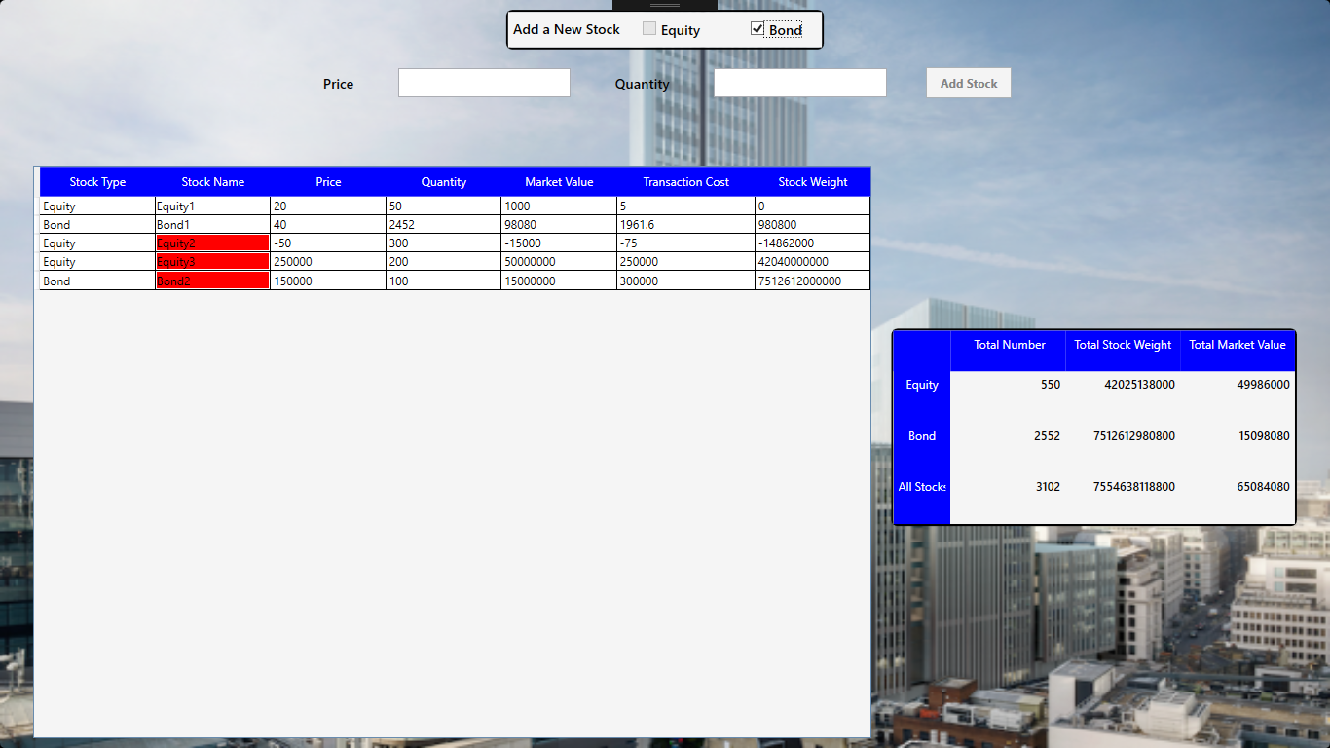

Also, on hovering mouse over stock item, Row background is changed

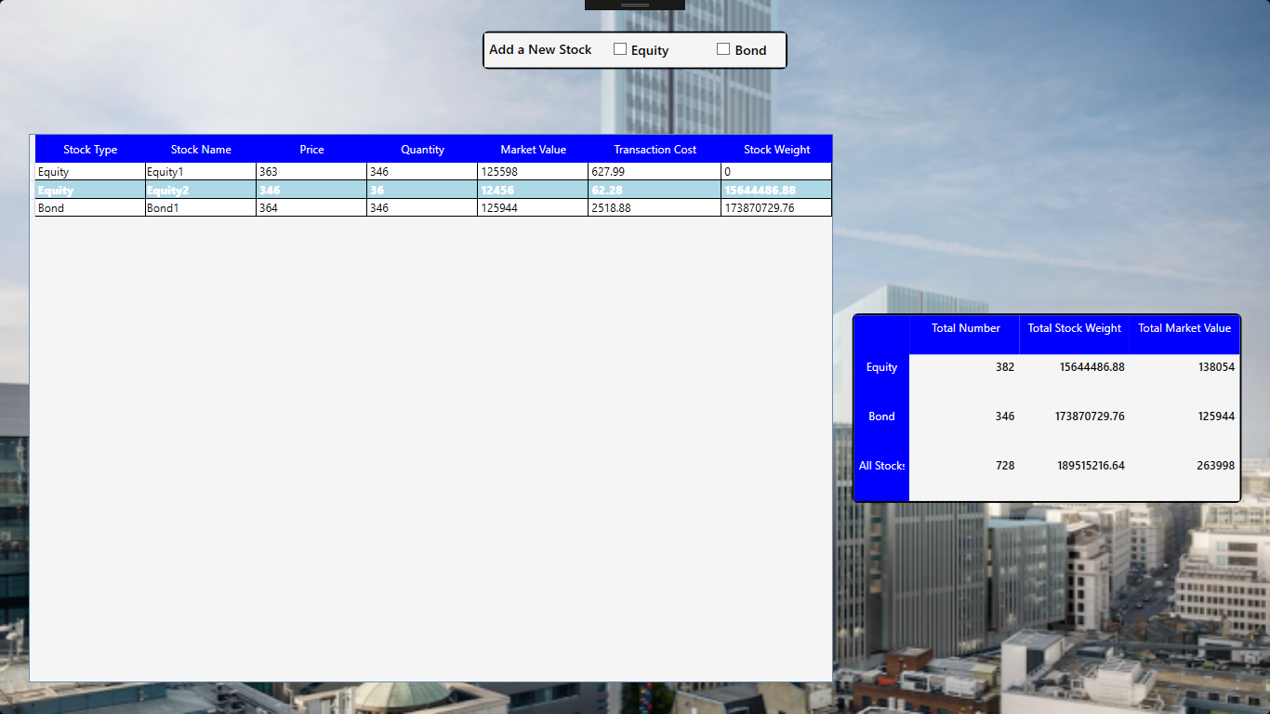

Pressing escape key on screen will close the window.